Blockchain Based Secure IOT Networks For Smart Cities.

Dr.C.Viji, Associate Professor
Dept of Computer Science and Engineering
Alliance School of Advanced Computing,
Alliance University,Bangalore , India Viji.c@alliance.edu.in

Karthik Rakesh
Dept of Computer Science and Engineering
Alliance School of Advanced Computing
Alliance University, Bengaluru,, India
rakarthikbtech22@ced.allaince.edu.in

Richard Roy
Dept of Computer Science and Engineering
Alliance School of Advanced Computing
Alliance University, Bengaluru, India
rrichardbtech22@ced.allaince.edu.in

Joel Kochukunju
Dept of Computer Science and Engineering
Alliance School of Advanced Computing
Alliance University, Bengaluru, India
kjoelbtech22@ced.allaince.edu.in

Abstract: The rapid IoT implementation in smart cities is effectively making everything networked but that has resulted in significant security and privacy issues. However, centralized security models can no longer support the range and quantity of devices and we are considering a blockchain-based implementation that combines anomaly detection based on AI with a 2 tiered architecture: PoA to check devices at their lightweight level and PBFT to implement the consensus between cities. We are also implementing ECC and AES 256 to maintain the authenticity and confidentiality and still operate on low power nodes. Thirdly, the AI becomes activated when threatening patterns are observed and serves to create a flag or even neutralize them in real time. The Raspberry Piperated simulation, and federated learning models demonstrate that we can achieve lower latency, more accurate detection, and the only additional calculating burden, and thus the system manages to be scaled and future-proof in terms of smart city implementations.

- Introduction

Global cities are actually smart nowadays, as virtually everything sensors, cameras, vehicles, and machines are interconnected through the internet. According to that, network connectivity assists in the regulation of traffic, energy conservation, and a better understanding of general citizenship. However, the reverse existence is that they can also be attacked by hackers to have stolen or destroyed data.

The majority of IoT devices are small and not particularly strong, and they are, therefore, unable to execute heavy security programs. Combine with it the older systems which are centralized, i.e., all traffic flows in through a single server, and you are guaranteed to have a disaster in case that server crashes or is compromised.

We are resorting to blockchain to address this, and to achieve this, we are distributing the information to many nodes, rather than one central node, which will be harder to tamper with. Nevertheless, the ordinary blockchains are bulky and slow when it comes to IoT. Therefore, this project proposes a hybrid scheme of blockchaining, the device layer employs PoA to ensure rapid and light verification, whereas the city layer pores on PBFT to ensure a stronger consensus. Overcoming it is AI that is scanned continuously inspecting the network and identifying the presence of something strange or malicious (which enhances the level of network security).

The idea is to create a system which is secure, rapid, and eco-friendly in terms of the small resources of the smart city IoT hardware. We have been experimenting on the use of Raspberry Pi boards and we are testing its sustainability in real-time situations.

- Related Work

The internet of things (IoT) and blockchain coming together have received significant interest in developing secure and scalable smart cities. They do deal with such major cybersecurity issues as integrity of data, authentication, and trust over various IoT systems-but that is also what is behind the integration. Previously, a decentralized architecture was suggested that substitutes the conventional centralized system of blockchain based authentication enhancing reliability and single joint breakdown of municipal IoT networks [1]. The transfer of the IoT data exchange models to distributed models will guarantee transparency and verifiability of communication between the smart city nodes [6], [21].

The most common areas that have been studied are security and authentication. Smart cities are better with blockchain based systems because accountability and auditability are enhanced as smart cities can conduct point to point authentication without the central authority [1]. In order to support IoT devices which struggle with resources, the proposed solution is to employ lightweight blockchain authentication systems, which do not sacrifice cryptographic security [11], [12]. When these papers are combined, they demonstrate that blockchain can give security to devices and the services at the device level [1], [12], [20].

Privacy preserving computation with blockchain IoT analytics is also another critical dimension. Machine learning based on privacy, data collection using encryption and secure multiparty computation have all demonstrated impressive outputs in keeping the user data confidential [3]. Whereas these methods increase privacy, large deployments require additional computing (and increased complexity), particularly when using large networks [3], [15]. Scalability and latency are, therefore, the leading issues of privacy-integrated blockchain systems.

Numerous compilations have proposed the lightweight consensus and energy-saving grouping plans to facilitate blockchain activities in low energy sensor networks [4], [18]. These protocols are capable of maintaining the fundamental security property of a blockchain but can be traded off during expansion to larger cities [4], [18].

The other important and critical area of focus is device lifecycle management. Introduced based on blockchain platforms, smart contracts allow tracking and updating events, which establish provenance and immutability during the lifecycle of firmware in a device and integrate and authenticate device integrity [5]. These technologies can, to a large extent enhance transparency in multivendor environments which is widely present in smart cities but the additional computational complexity has to be made cost effective to be able to do so with scaling [5].

Researchers have also paired fog and edge computing with blockchain in an attempt to address the issue of response-time in applications that are time-sensitive. The hybrid architecture, which combines the use of local consensus protocols on the fog nodes with permissioned blockchains, will allow near-real-time decisions to be made when providing services such as the control of traffic and responding in emergencies [8], [11]. Such integration increases responsiveness and at the same time adds some complexities in the distribution of trust and data synchronization [8].

There are still domain specific solutions that continue to demonstrate the usefulness of blockchain in the smart city environment. As an example, IoT systems based on blockchain have been used to administer civic engagement, public services, and supply chain visibility, increasing the level of traceability, fairness, and civic engagement [9], [13]. These applications reflect the wider application of blockchain with respect to security to foster transparency, accountability, and governance in the activities of cities [9], [13].

And there are open challenges that have not yet been solved after these breakthroughs. Due to the low consensus and high storage consistency, compatibility and scalability continue to limit the use of blockchain in large IoT networks. Although privacy preservation rules enhance confidentiality, they tend to increase energy and computational requirements. It is why the recent articles are driving the lightweight consensus, off-chain storage, and China-hybrid models as potential solutions. [13], [20]

Altogether, in the literature, blockchain is perceived as a potential enhancer of the smart cities in terms of secure, transparent, and reliable IoT infrastructure. Nonetheless, scalability, compatibility, and energy efficiency are still the challenges, which encourages the planning of lightweight adaptable blockchain architectures capable of becoming automatically integrated parts of various urban IoT ecosystems. [1], [8], [5], [18], [20].

- Proposed Methodology

- System Architecture

We have structured our system into two layers namely: the Device layer and the City layer. The Device layer is an operating system on IoT devices like sensors or gateways and it is based on Proof-of-Authority (PoA). Transactions are approved by only trusted devices, being rapid and bandwidth friendly. The City layer bridges the entirety of the device blockchains and leverages PBFT that is more robust and is capable of safeguarding bigger data. The combination of the two layers renders the network fast and secure.

- Cryptographic Techniques

Our data security encryption is Elliptic Curve Cryptography (ECC) and AES 256. ECC signs and authenticates messages and works effectively on small devices and the AES 256 encrypts data on the fly. We also include the functionality of SHA-3 hash which is difficult to alter and come up with an update after the data has been stored.

- AI-Based Threat Detection

Threat detection also assists us in identifying any suspicious activity in the network since the AI is trained on the City layer, which is rather strong. Through federated learning, the system gets to learn through other devices without any insights into their confidential information. It is able to automatically block any malicious devices, revoke network access, or reset keys; this offers protection to the network without requiring a human operator.

- Communication Protocol

The mesh network with the IEEE 802.15.4 standard is the most captivating feature of our design that we use to communicate between devices. It is less power consuming and is effective in the internet of things. To transfer data between the city and device layers, we offer the DTLS over UDP that ensures the safety of the data when the connection is not stable.

- Implementation and Testing

In order to test our system, we used prototypes of Raspberry Pi and ARM Cortex board, and tested the City layer on a more powerful computer. All the related learning tools were utilized in training the AI. The measures we considered during the evaluation of the system were latency (the speed at which data is exchanged), power consumption (energy consumption), speed of transactions (number of messages that AI can analyze per second), detect rate (retrieval of attacks without human intervention by AI),
and scalability (performance as the number of devices increases).

The outcomes demonstrated that the system was effective, quick, consumed minimal energy, and it was able to identify as well as detect an attack in a quick period

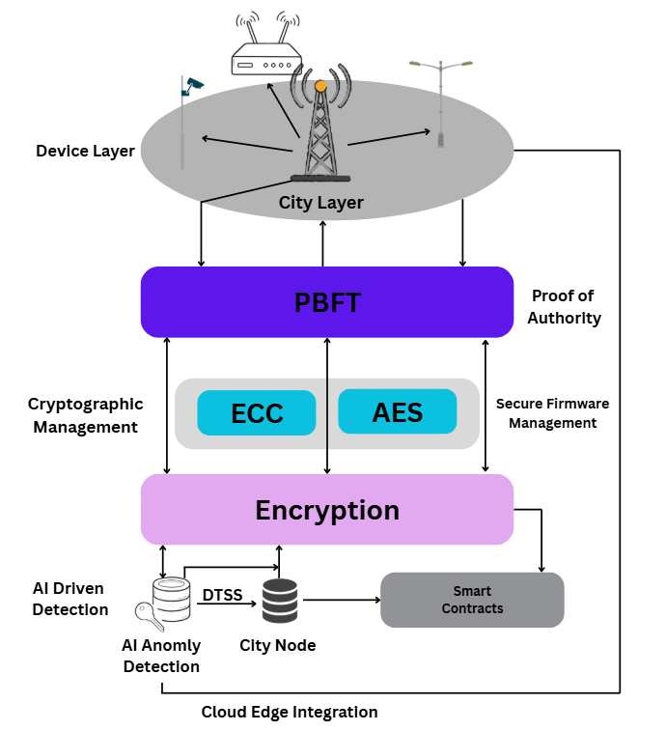
Figure. 3.1

- Result Analysis

This has been successful in ensuring the protection of the IoT in smart cities through the hybrid blockchain model in combination with the AI assisted threat detection without compromising on its operations. We conducted experiments of IoT nodes based on Raspberry Pi and simulated a city with resource limitations measuring the latency, throughput, energy consumption and security resiliency.
Latency test demonstrates that transaction validation time is reduced when using Proof of Authority (PoA) consensus at the device level (as opposed to traditional consensus mechanisms such as Proof of Work) and provides nearly real-time device communication and authentication. The Practical Byzantine Fault Tolerance (PBFT) layer to guarantee high throughput and reliable consensus as the number of nodes
increases ensures the framework is flexible to successful deployments in wider city areas.

It has been measured that lightweight cryptography, which includes elliptic curve cryptography (ECC) to sign digital messages and AES 256 symmetric encryption, is enough to make the framework battery friendly, IoT devices. This will increase efficiency and network life compared to traditional blockchain IoT systems where more weight cryptography loads are required.

We trained various AI models using normal and malicious traffic and tested them to determine the behavior of anomaly detection. The findings indicate that there is a high detection rate of such attacks as the flood of packets, spoofing and unwarranted use, and there are not many cases of false positives. Integration of smart contracts offers self-reactions by isolating suspicious nodes and rotating keys causing less manual intervention and fast reaction time.

Secure multi hop routing using IEEE 802.15.4 mesh networking on top of the Datagram Transport Layer Security (DTLS) over UDP supported strong data integrity and confidentiality even when test conditions are set to simulate stress to the network by addressing a larger number of nodes and varying delay conditions characteristic of an urban wireless network. According to that, communication integrity is critical to continuous smart city services.

To sum up, the findings indicate that the proposed framework provides an energy efficient, adaptable, and scalable security system of heterogeneous IoT devices in cities. It highlights the advantages of decentralized blockchain with the feature of proactive defense of AI, which opens the opportunities of a safe, self-governing, long-term IoT system in urban environments.

- Conclusion and Future Works

The possibility of the combined blockchain and IoT system in the smart cities presenting an incredibly efficient answer to the challenges of intricate security issues of the urban environment is a great option. We will apply a Proof of Authority based lightweight blockchain at the device layer and Practical Byzantine Fault Tolerance-based city layer blockchain, which will provide a scalable and power conscious solution in ensuring data integrity, authentication, and trustworthiness across diverse IoT devices. Our security schemes including elliptic curve cryptography and AES 256 are then combined to improve security.

This framework, as indicated by experimental findings, substantially lowers the latency and the computational overhead whilst still being highly accurate in identifying data, which lends credibility to the framework applicability in implementing smart cities in real world applications. It also demonstrates a high level of scalability, energy efficiency, and responsiveness, which reflects the potential of the
framework in becoming a future basis of the smart IoT network.

In the future, studies need to work on creating partnerships with the existing infrastructure systems in the city and increasing flexibility to solve the requirements of the future IoT standards. Over time, smart cities will be much more efficient with the help of blockchain technologies combined with AI and new computer technologies.

- References

- Blockchain Based Secure Communication for IoT Devices in Smart Cities - Ramazan Yetis and Ozgur Koray Sahingoz.
- Convergence of Blockchain and IoT for Secure Transportation Systems in Smart Cities - Khizar Abbas, LoAi A. Tawalbeh, Ahsan Rafiq, Ammar Muthanna, Ibrahim A. Elgendy, Ahmed A. Abd El-Latif.
- PPSF: A Privacy-Preserving and Secure Framework Using Blockchain-Based Machine-Learning for IoT-Driven Smart Cities - Prabhat Kumar, Randhir Kumar, Gautam Srivastava, Govind P. Gupta, Rakesh Tripathi, Thippa Reddy Gadekallu, Neal N. Xiong.
- A blockchain-based approach for secure energy-efficient IoT-based Wireless Sensor Networks for smart cities - Hamad Aldawsari.
- Blockchain-Based Secure Device Management Framework for an Internet of Things Network in a Smart City - Seonghyeon Gong, Erzhena Tcydenova, Jeonghoon Jo, Younghun Lee, Jong Hyuk Park
- Securing Smart Cities Using Blockchain Technology - Kamanashis Biswas, Vallipuram Muthukkumarasamy
- Blockchain Based an Efficient and Secure Privacy Preserved Framework for Smart Cities - Adla Padma, Mangayarkarasi Ramaiah
- A blockchain and artificial intelligence enabled smart IT framework for sustainable city - Imran Ahmed, Yulan Zhang, Gwanggil Jeon, Wenmin Lin, Mohammad R. Khosravi, Lianyong Qi
- An IoT and Blockchain-Based Secure and Transparent Supply Chain Management Framework in Smart Cities Using Optimal Queue Model - Ahmad Yahiya Ahmadad Bani Ahmad, Neha Verma, Nadia Mohamed Sarhan, Emad Mahrous Awwad, Amit Arora, Vincent Omollo Nyangaresi
- A Blockchain Model for Trustworthiness in the Internet of Things (IoT)-Based Smart Cities. - Rashid Ali, Yazdan Ahmad Qadri, Yousaf Bin Zikria, Fadi Al-Turjman, Byung-Seo Kim, Sung Won Kim
- Blockchain and Fog Based Architecture for Internet of Everything in Smart Cities.- Parminder Singh, Anand Nayyar, Avinash Kaur, Uttam Ghosh
- Blockchain-Based Authentication and Trust Management Mechanism for Smart Cities. - Muhammad Asif, Zeeshan Aziz, Maaz Bin Ahmad, Adnan Khalid, Hammad Abdul Waris, Asfandyar Gilan
- On the Design and Implementation of a Blockchain Enabled E-Voting Application Within IoT-Oriented Smart Cities. - Geetanjali Rathee, Razi Iqbal, Omer Waqar, Ali Kashif Bashir
- Integrating AI and Blockchain for Enhanced Data Security in IoT-Driven Smart Cities - Burhan Ul Islam Khan, Khang Wen Goh, Abdul Raouf Khan, Megat F. Zuhairi, Mesith Chaimanee
- Optimal Machine Learning-based Intrusion Detection System for Privacy Preserving BIoT with Smart Cities Environment. - A. Al-Qarafi, F. S. Alrowais, S. S. Alotaibi, N. Nemri, F. N. Al-Wesabi, M. Al Duhayyim, R. Marzouk, M. Othman, and M. Al-Shabi.
- Energy-Efficient and Blockchain-Enabled Model for Internet of Things (IoT) in Smart Cities. - Norah Saleh Alghamdi and Mohammad Ayoub Khan.
- Blockchain-based security algorithm on IoT framework for shielded communication in smart cities - K. Priyadharshini and R. Aroul Canessane.
- A blockchain-based approach for secure energy-efficient IoT-based Wireless Sensor Networks for smart cities - Hamad Aldawsari
- A Blockchain-Based Architecture and Framework for Cybersecure Smart Cities - Abla El Bekkali, Mohamed Essaidi, and Mohammed Boulmalf
- Smart contract-based security architecture for collaborative services in municipal smart cities - Kamanashis Biswas, Vallipuram Muthukkumarasamy
- A Blockchain-based approach for secure IoT. - Sonia Kotela, Fatma Sbiaab, Raouda Maraoui Kamoun, and Lazhar Hamel

